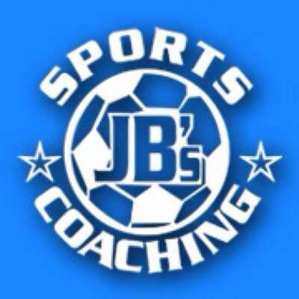  JB’s Holiday Activities  Yr 5 and 6 Striking and Fielding  Name …………………………………….  Class………………………………………  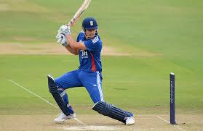 | How much can you remember about Striking and Fielding?  Q1) What is the difference between an overarm cricket bowl and an overarm throw?  ……………………………………………………………………………………………………  Q2) Name 4 positions/roles in Rounder’s or Cricket?  ……………………………………………………………………………………………………  Q3) Why would you use a one handed pick up as a fielding technique?  ……………………………………………………………………………………………………  Q4) Why do you line you body up with the ball first when fielding?  …………………………………………………………………………………………………  Q5) In cricket and golf, does your weaker hand typically go at the top, or bottom of the grip?  ……………………………………………………………………………………………………  Q6) Name 3 ways you can be out in cricket or rounders?  ………………………………………………………………………………………………….
Can you try the following?  - Can you bowl overarm at a target 10 times and record how many times you hit the target?  Score…………………..  - Can you throw a ball from a distance of 20 steps to hit a chosen target in fewest attempts possible?  Attempts………………..  - Can you perform 10 consecutive catches from a ball thrown by a partner at varying heights and speeds?  - How many overarm bowls can you hit from 6 balls? Score……………….  - Can you hit the ball further than 20 steps either with a cricket/rounders bat from a bowl, or with a golf club from the floor?  _____________________________________________________  My …………………………………………… helped me try these challenges in the holiday.  Adult Signature …………………………………………………………………….. | Can you complete this word search?  