JB’s Holiday Activities  Yr 5 and 6 Net/wall  Name …………………………………….  Class………………………………………  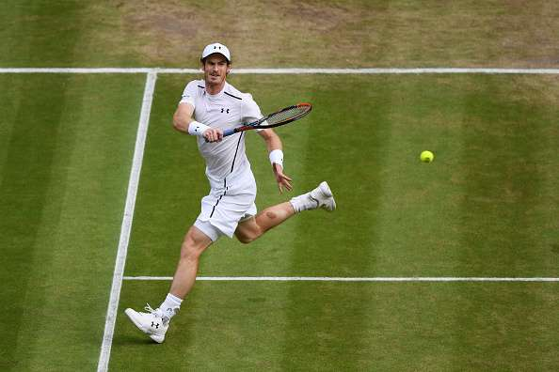 | How much can you remember about Net/Wall?  Q1) What defines a volley?  ……………………………………………………………………………………………………  Q2) Name 3 shots that you have used in your topic in P.E this term?  ……………………………………………………………………………………………………  Q3) What is your preferred technique and why?  ……………………………………………………………………………………………………  Q4) If playing a competitive game, whereabouts on the opponent’s half of the court would try to hit the ball?  …………………………………………………………………………………………………  Q5) Why is your footwork important in Net/Wall games?  ……………………………………………………………………………………………………  Q6) Your body should always be facing what when you are moving around the court?  ………………………………………………………………………………………………….
Can you try the following?  - Can you perform 5 successful shots with the weaker side of your body?  - Can you successfully perform 3 different shots with good technique in a sport of your choice?  - Can you maintain a 10 shot rally with a partner?  - Can you maintain a 5 shot rally with a partner over an obstacle?  - Can you keep a ball up using just your hands to hit it for 1 minute?  _____________________________________________________  My …………………………………………… helped me try these challenges in the holiday.  Adult Signature …………………………………………………………………….. | Can you name these Tennis players?  ………………………………………………. …………………………………………….  ………………………………………………. …………………………………………....

