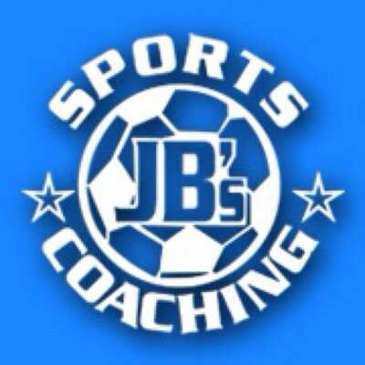  JB’s Holiday Activities  Yr 5 and 6 Gymnastics  Name …………………………………….  Class………………………………………  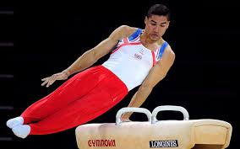 | How much can you remember about Gymnastics?  Q1) Name three shapes you could make in the air?  ……………………………………………………………………………………………………  Q2) What is meant by counter balance?  ……………………………………………………………………………………………………  Q3) What is meant by body tension?  ……………………………………………………………………………………………………  Q4) Why is good body tension required for gymnasts?  …………………………………………………………………………………………………  Q5) Unless told otherwise, how many people should carry a piece of apparatus?  ……………………………………………………………………………………………………  Q6) Draw a stick man version of two people making a synchronized shape?
Can you try the following?  - Create the synchronized shape that you have drawn and hold as a balance?  - Can you perform 2 shapes within 1 jump?  - Can you perform a 3 bridge sequence, including a front, back and side bridge?  - Can you hold 3 different balances on either 2 or 3 points of contact?  - Can you create a sequence incorporating a roll, spin/rotation, balance and four different linking movements?  _____________________________________________________  My …………………………………………… helped me try these challenges in the holiday.  Adult Signature …………………………………………………………………….. | Can you name these pieces of gymnastics equipment and events ?     

