JB’s Holiday Activities  KS 1 Dribbling, Kicking and Hitting  Name …………………………………….  Class………………………………………  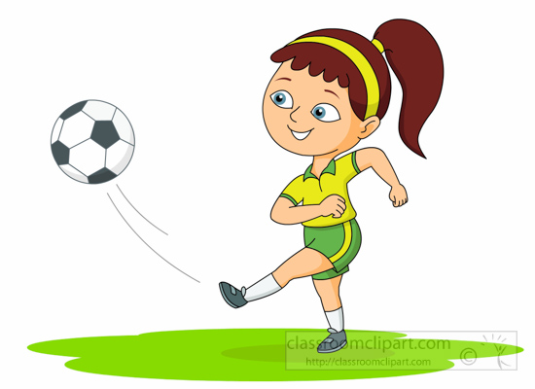 | How much can you remember about dribbling and kicking?  Q1) When dribbling, the ball must be under your what?  ………………………………………………………………………  Q2) What size touches should you take when dribbling?  ………………………………………………………………………  Q3) Name one thing you could do to help get the ball to the target when kicking or hitting?  ………………………………………………………………………  Q4) When kicking a ball, what does the non-kicking foot do?  ………………………………………………………………………
Can you try the following?  - Can you dribble a ball without losing control when travelling at different speeds?  - Can you dribble using the inside, outside and sole of your foot?  - Can you dribble around obstacles without hitting them?  - Can you pass a ball to a partner 10 times?  - Can you score a goal from 5-10 steps away, with or without a goalkeeper?  _________________________________________________________  My …………………………………………… helped me try these challenges in the holiday.  Adult Signature …………………………………………………………………….. | Can you complete the word search?  