JB’s Holiday Activities  Yr 5 and 6 Dance  Name …………………………………….  Class………………………………………  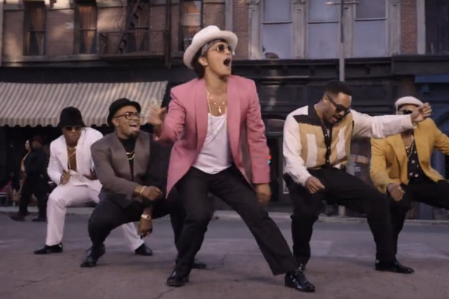 | How much can you remember about Dance?  Q1) Name 4 dance styles?  ……………………………………………………………………………………………………  Q2) What is meant by tempo?  ……………………………………………………………………………………………………  Q3) What is meant by rhythm  ……………………………………………………………………………………………………  Q4) How could you create a beat to dance to without playing music?  …………………………………………………………………………………………………  Q5) How does the music dictate the style of dance?  ……………………………………………………………………………………………………  Q6) What skills are important when dancing?  ………………………………………………………………………………………………….
Can you try the following?  - Create your own dance to a song of your choice?  - Can you create a dance incorporating 3 dance styles?  - Can you copy the dance movements from a music video of your choice?  - Can you create a beat for somebody else to dance to?  - Can you perform a dance from Just Dance? These can be found on YouTube  _____________________________________________________  My …………………………………………… helped me try these challenges in the holiday.  Adult Signature …………………………………………………………………….. | Can you watch a YouTube clip of the musical dance group called STOMP to further understand rhythm and beat?

